**Switch Node**

These demo’s test X3D’s Switch node using JavaScript and TouchSensors to change which mesh inside the Switch should be displayed.

**switchnode00.x3d**

The X3D file opens with the Switch node’s ‘whichChoice’ set to 1, which displays the yellow Cone. Rolling over the blue Cylinder calls JavaScript code to change ‘whichChoice’ to 2 and display the flat green Cylinder. Rolling off the blue Cylinder canges ‘whichChoide’ to display the blue Sphere.

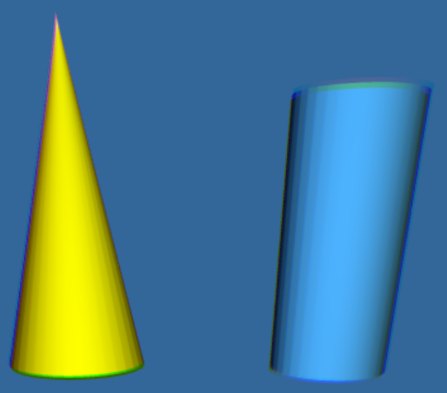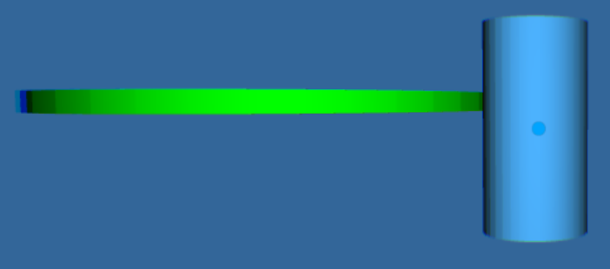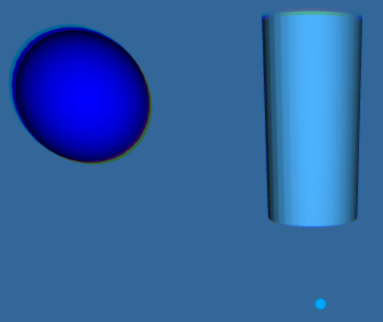

**switchnode01.x3d**

As the previous example, the scene opens with yellow Cone. Rolling over the blue Cylinder will cycle through all the meshes in the Switch node: red Box, yellow Cone, a flat green Cylinder and a blue Sphere. The JavaScript was designed to sequence one beyond the 4 objects in the Switch node and thus will show one scene with no objects next to the right blue Cylinder.

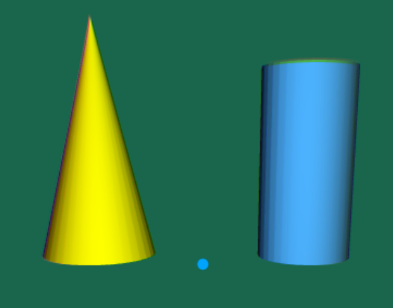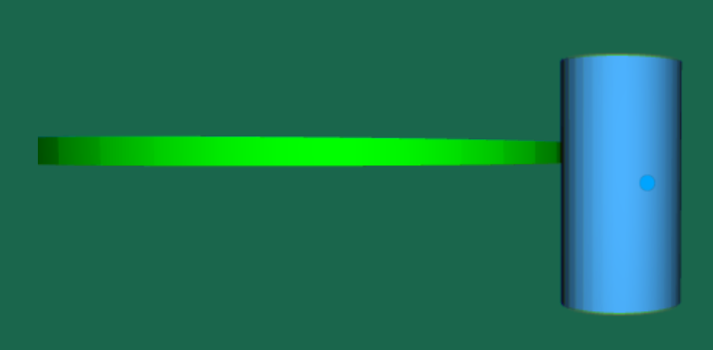

**switchnode02.x3d**

The opening scene show 5 objects (now added a teapot) with no object above, there are only mesh 0 through 3 in the Switch node, but ‘whichChoice’ is initialized to 4, so no object above should appear.

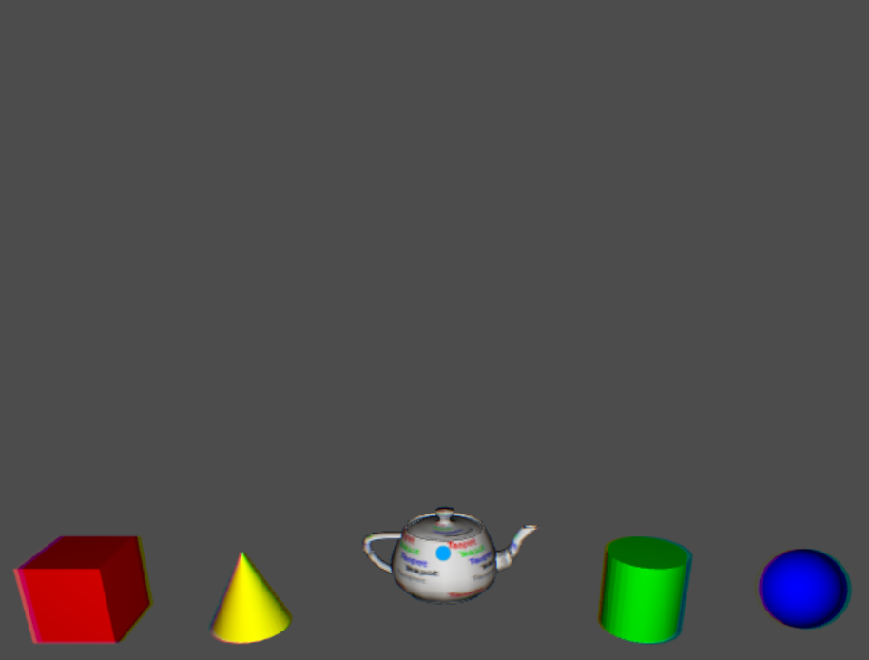

Rolling over the red Box displays a red Box (slightly rotated) above, the yellow Cone, flat green Cylinder and blue Sphere. Rolling over the teapot display nothing (like above) since only 4 meshes are in the Switch node, and the JavaScript associated with the teapot set ‘whichChoide’ to 4, which is not in the Switch node.

